1. Create a new GitHub repository.

* Clone the repository to your local machine using SSH (generate an SSH key if needed, add the public key to your GitHub account).

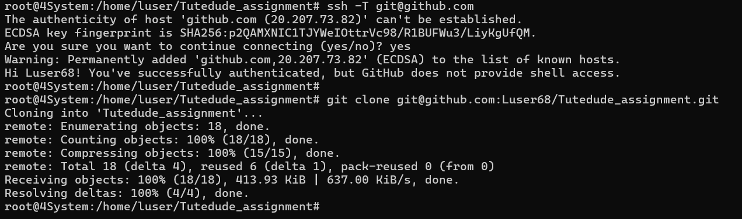

* Create a new branch named after your username (e.g., Tutedude).



* Add your Flask project files to this branch.
* Commit the changes and merge the branch into the main branch.

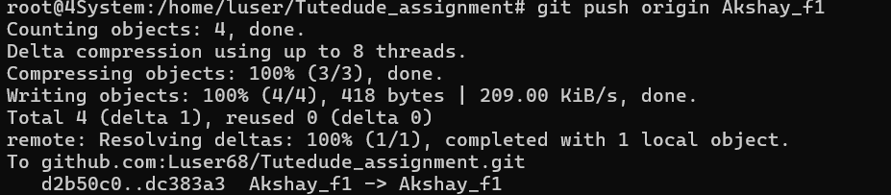

2. Create a new branch named <your_name>_new (e.g., Tutedude_new).

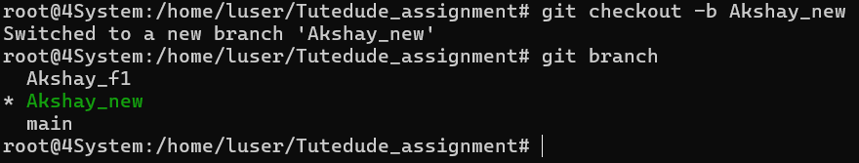

* Update the content of the JSON file used for the /api route in this branch.
* Merge the <your_name>_new branch into the main branch.

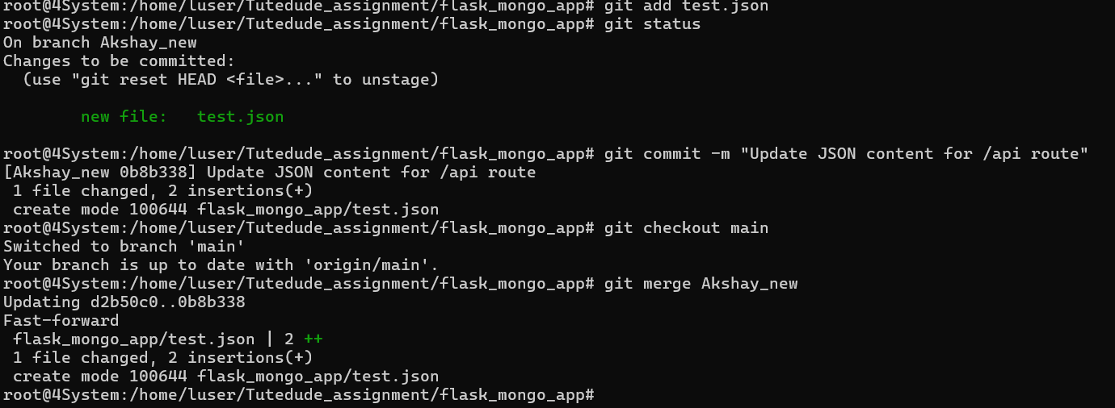

* If there are conflicts during the merge, resolve them by accepting the changes from the <your_name>_new branch.
* Add the resolved changes to the staging area, commit them, and push the updates to the remote repository.

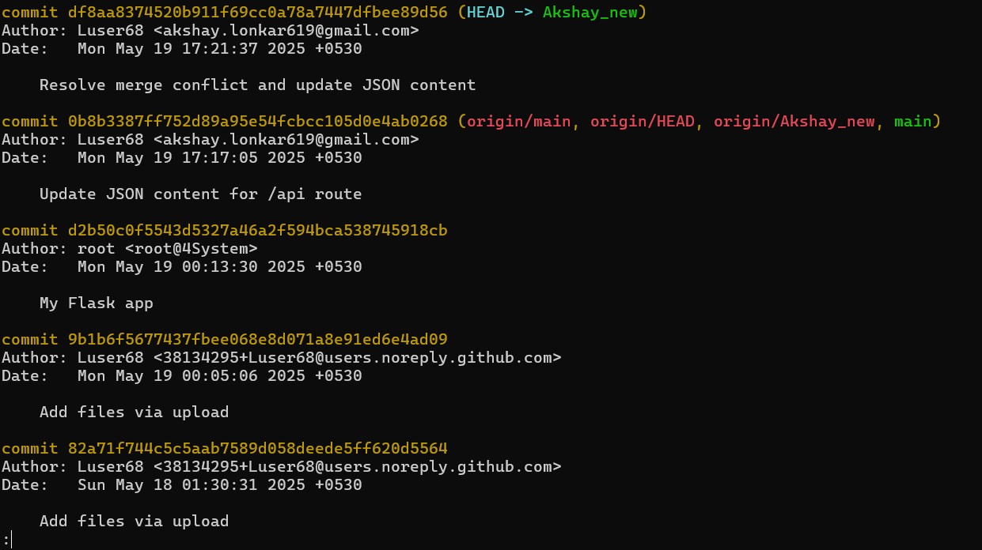

3. **Branch Creation**:

* Create two branches: master_1 and master_2 from the main branch.



* **Feature Development in** master_1:
* In the master_1 branch, create a **To-Do Page** in the frontend.
  + The page should contain a form with the following fields:
    - **Item Name**
    - **Item Description**

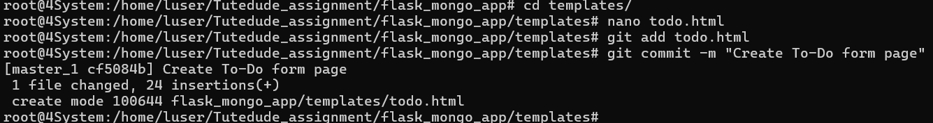

* **Backend API in** master_2:
* In the master_2 branch, create a backend route named /submittodoitem.
* This route will:
  + Accept itemName and itemDescription via a POST request.
  + Store these details in a MongoDB database.

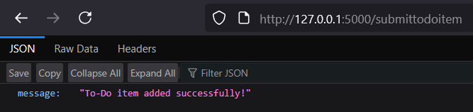

* **Merging Changes**:
* Merge the changes from both master_1 and master_2 into the main branch.

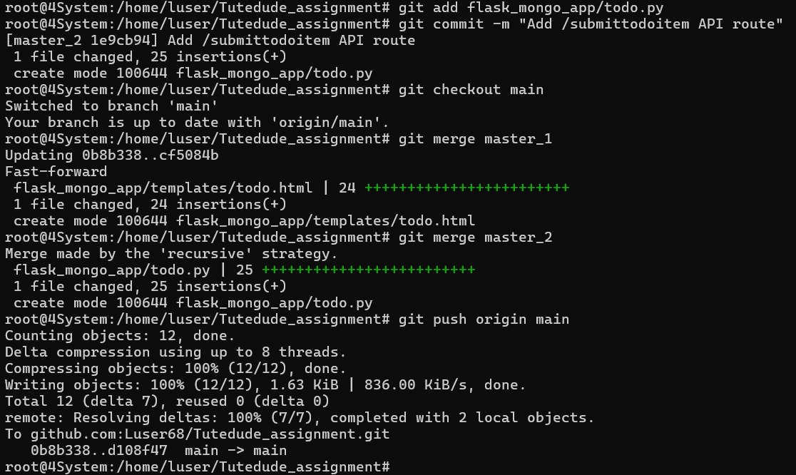

4. **Enhancing the To-Do Form in** master_1:

* In the master_1 branch, add the following fields to the To-Do form:
  + **Item ID**
  + **Item UUID**
  + **Item Hash**
* **Committing in Sequence**:
* Add and commit each field separately in the following order:
  + **First commit**: Add **Item ID** field.
  + **Second commit**: Add **Item UUID** field.
  + **Third commit**: Add **Item Hash** field.

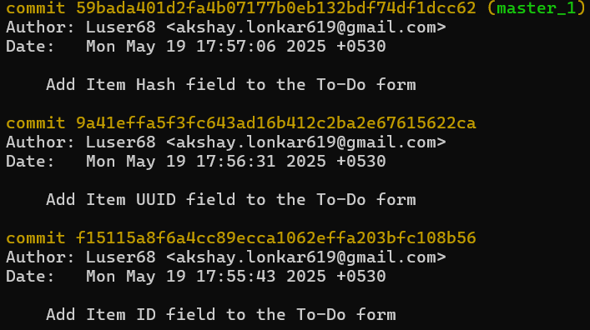

* **Merging to** main:
* Merge the master_1 branch into the main branch.



* **Git Reset and Commit Deletion**:
* In the main branch, use **Git Reset** to roll back to the commit where only the **Item ID** field was added.
* Use git reset --soft to ensure changes remain staged.

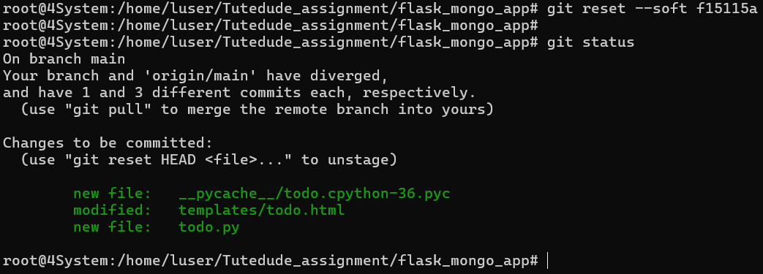

* Re-commit this state to the main branch.
* Merge this updated state to the main branch.
* **Rebasing Changes**:
* Rebase the updated changes in the main branch to the master_1 branch.  
  **Clarification**:
  + During rebasing, **preserve individual commits** to maintain the commit history for each change (i.e., do not squash commits).
  + Use git rebase main master_1 to integrate changes from the main branch back into the master_1 branch.

**Submission Guidelines -:** Attach Screenshots or command along with explanation and submit in doc(google doc or microsoft doc) format , also share link of your github repo